**KOCAELİ UNIVERSITY ENGINEERING FACULTY**

**STEPPER MOTOR PMOD REFERENCE DOCUMENT**

FURKAN YARDIMCI

2021-2022

**DEPARTMENT: Electronic and Communacition Engineering**

**TEACHER: Associate Profesor ANIL ÇELEBİ**

**KOCAELİ, 2021**

TABLE OF CONTENTS

TABLE OF CONTENTS 2

LIST OF FIGURES 2

LIST OF TABLES 2

PURPOSE OF THE PROJECT 3

INTRO/OVERWİEV 3

FEATURES 3

CONNECTİONS/INTERFACING 3

STEPPER MOTOR CONTROL 4

VERILOG HDL 5

* CODE 5-9

- PMOD_STEP_DRIVER.V5-7

- CLOCK_DIV.V8

- PMOD_STEP_INTERFACE.V9

SCHEMATIC 10

BORD LAYOUT 10-12

MATERIAL LIST 13

REFERENCES 14

LIST OF FIGURES

STATE DIAGRAM OF THE CODE 5

SCHEMATIC OF THE CIRCUIT10

TOP 10

BOTTOM 11

TOP/BOTTOM 11

FOTAGE OF THE CIRCUIT(TOP) 12

FOTAGE OF THE CIRCUIT(BOTTOM) 12

MATERIAL LIST 13

LIST OF TABLES

TABLE OF CONTENTS 4

PURPOSE OF THE PROJECT4

**PURPOSE:**

The purpose of this document is to provide a document containing the necessary features about the design and use of stepper motor pmod, prepared by Kocaeli University Students FURKAN YARDIMCI and ASLINUR SERİN.

**İNTRO/OVERWİEV:**

The pmod stepper motor module provides the required number of headers to drive the 4-pin bipolar and 6-pin unipolar stepper motors with the Basys-3 board. Stepper motors are structures that contain magnets and coils that polarize this magnet to provide movement. When electric current passes through the coils in stepper motors, the motor creates torque due to the magnetic field created by this current. Each movement of this motor is called a step. The inputs of the Basys-3 card cannot provide this current required for the step motor to work. With the current/power amplifier circuit consisting of LM293D and mosfets on the pmod stepper module, it increases the low current it receives from the Basys-3 card to the levels that required for driving the stepper motor. In this way, the stepper motor is driven.

**FEATURES:**

* Stepper motor driver for 4 and 6-pin motors
* Can drive both motors simultaneously
* Multiple LEDs to indicate signal propagation
* Jumper for optional external power
* 2×6-pin pmod connector with GPIO interface

**CONNECTİONS/INTERFACİNG:**

The Pmod STEP communicates with the host board via the GPIO (General-purpose input/output) protocol. Microcontrollers usually include GPIOs. Depending on the application, a microcontroller's GPIOs may comprise its primary interface to external circuitry or they may be just one type of I/O used among several, such as analog signal I/O, counter/timer, and serial communication.

This Pmod offers headers for both 4-pin and 6-pin stepper motors. 4-pin stepper motors only work in the bipolar configuration, requiring that the two inputs on each electromagnetic coil are brought to the correct logic level voltages to induce current flow in the correct direction. The 6-pin stepper motor header on this Pmod can be oriented for either bipolar or unipolar configuration. The two extra pins on this header provide two positive power pins as a source of current for when an input on one end of a coil is driven to a logic low voltage level.

|  |  |
| --- | --- |
| **SM PMOD Reference Designator** | **Function** |
| **P2** | This pin 2x6, right-angle header provides VCC, GND and (8) digital 1/0 signals from the Basy3's microcontroller to the SM PMOD through any of the Pmod connector ports on the Basys-3. |
| **P3** | 4-wire stepper motor interface connector. |
| **P4** | 6-wire stepper motor interface connector. |
| **P9** | This header provides access to pins 1-4 of  the SM PMOD header J1 (labeled SIG1-SIG4 on the SM PMOD schematic). |
| **P10** | This header provides access to pins 5-8 of the SM PMOD header J1 (labeled SIG5-SIG8 on the SM PMOD schematic). |
| **P7** | GND |
| **P8** | GND |
| **P6** | External power screw terminal block. Provide power to the SM PMOD from an external source rather than from the Basys-3 board.  NOTE: Pins 1 and 3 of P5 must be shorted (pins 2 and 3 of P5 open) to power the SM PMOD from an external source. |
| **J1** | External power measurement point. Use P7 or P8 (GND) on SM PMOD as the return to measure the voltage of the external power applied to the board. |
| **P5** | Power selection jumper. Jumper (short) pins 1 and 2 of P5 to supply power from the external power screw terminal block P6 or jumper (short) pins 2 and 3 of P5 to supply power from the Basys-3 board. |
| **P1** | Digital I/O signal state indication LED power jumper. Install the jumper  (short pins 1 and 2) on P1 to provide power to bias the digital 1/0 signal state indication LEDs. Remove the jumper to reduce power consumption of board for battery powered applications. |

**TABLE 1.**

**STEPPER MOTOR CONTROL:**

**TABLE 2**

**VERİLOG HDL:**

We used a state machine to evaluate multiple situations, as it can give various outputs according to the polarization status of the stepper motor coils. The state diagram is as follows.

**Image 1**

**CODE:**

**PMOD_STEP_DRIVER.V:**

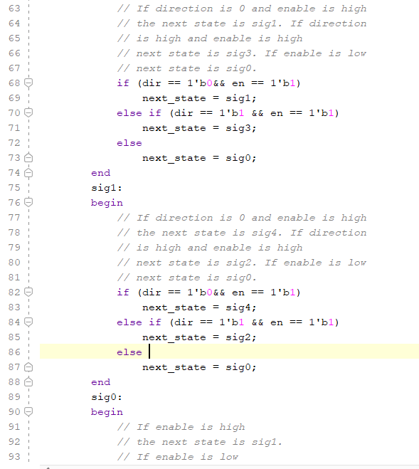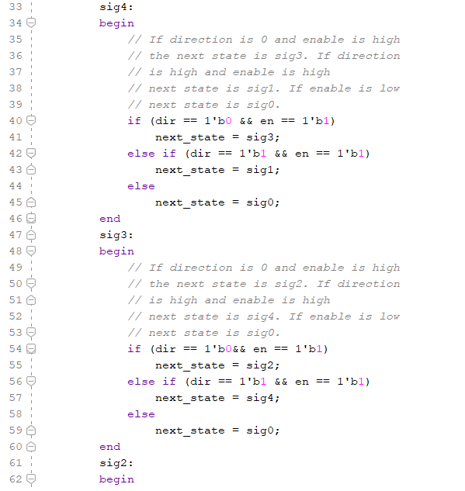

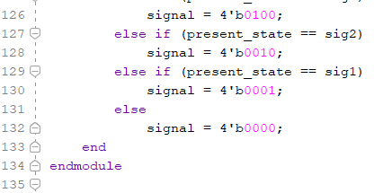

**CLOCK_DIV.V:**

**PMOD_STEP_INTERFACE.V:**

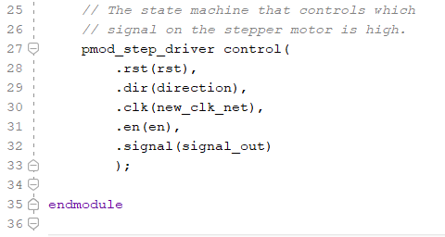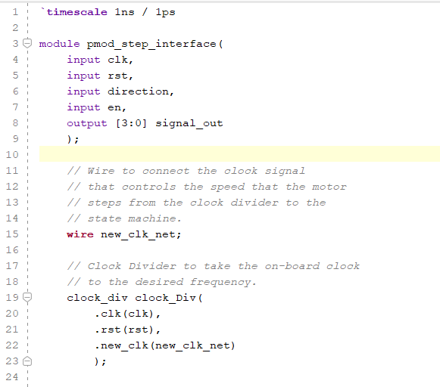

**SCHEMATIC:**

**Image 2**

**BOARD LAYOUT:**

**TOP:**

**Image 3**

**BOTTOM:**

**Image 4**

**TOP/BOTTOM:**

**Image 5**

**Image 6**

**Image 7**

**MATERIALS LIST:**

**Image 8**

**REFERENCES:**

* [**https://www.elektrovadi.com/urun/pmod-step-motor-surucu-pmod-stepper**](https://www.elektrovadi.com/urun/pmod-step-motor-surucu-pmod-stepper)
* [**https://digilent.com/reference/pmod/pmodstep/reference-manual?redirect=1**](https://digilent.com/reference/pmod/pmodstep/reference-manual?redirect=1)
* [**https://www.robocombo.com/blog/icerik/step-motor-nedir-ne-ise-yarar-nasil-calisir**](https://www.robocombo.com/blog/icerik/step-motor-nedir-ne-ise-yarar-nasil-calisir)
* [**https://digilent.com/reference/learn/fundamentals/communication-protocols/gpio/start**](https://digilent.com/reference/learn/fundamentals/communication-protocols/gpio/start)
* [**https://www.instructables.com/How-to-Control-a-Stepper-Motor-With-an-FPGA/**](https://www.instructables.com/How-to-Control-a-Stepper-Motor-With-an-FPGA/)
* [**https://www.youtube.com/watch?v=ePSCZ_DtF7c**](https://www.youtube.com/watch?v=ePSCZ_DtF7c)
* **https://howtomechatronics.com/how-it-works/electrical-engineering/stepper-motor/**